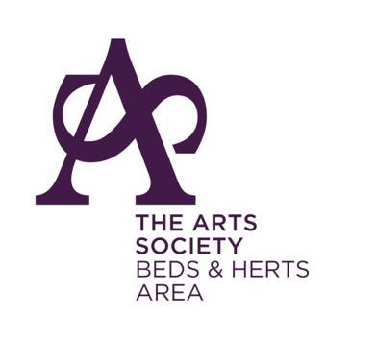

Beds & Herts Area
Visit

City of London Walking Tour, with Ian Swankie, and guided visit to the Guildhall Art Gallery
on two alternative dates: Friday 20th September and Friday 4th October

APPLICATION FORM

Application Form

Name(s) ……………………………………………………............

Telephone Number ………………………………………………………………..

Email ………………………………………………………………..

Society ………………………………………………………………..

In Case of Emergency Contact Number for Day of Visit ………………………………

Please tick one of the following:

I/We can only make the 20th September:

I/We can only make the 4th October:

I/We can make both dates:
My/Our preference is for 20th September/4th October/either (please delete as appropriate)

Cost £25 per person to include audio guide

Please pay by either

Online banking to:
The Arts Society - Beds and Herts Area, Account No. 20787825, Sort code 20 74 81, adding
Reference GH plus your surname and then email your application form to Gill Gowing at gmgowing@btopenworld.com

or by cheque payable to “The Arts Society - Beds and Herts Area” and post with your application
form to Gill Gowing, 94 Moor Lane, Rickmansworth, Hertfordshire. WD3 1LQ

Any queries, please contact:-

Gill Gowing at gmgowing@btopenworld.com or 01923 777715 or 07882761471

