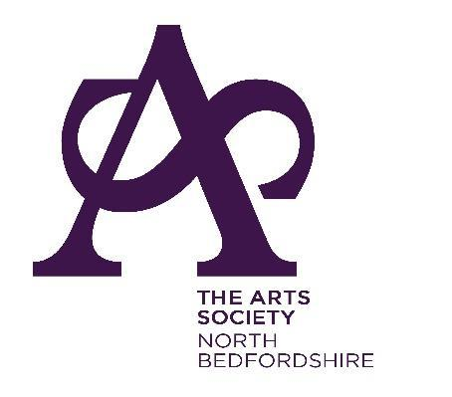

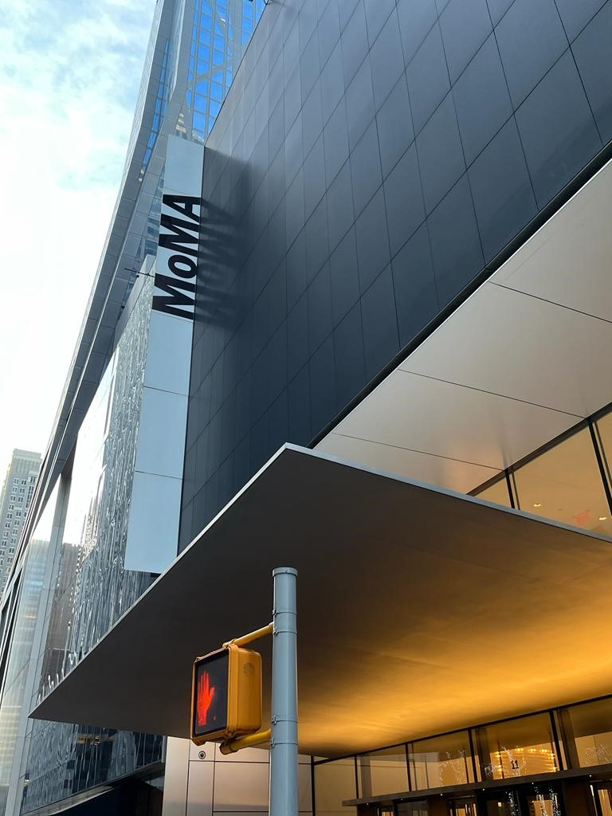

**A SPECIAL INTEREST ZOOM EVENT**

**Tuesday, 14 January 2025 – 2.00pm - 3.00pm**

**ANNA MOSZYNSKA - MOMA NEW YORK**

Cost: £12 members / £15 non-members.

**Please join us for this Special Interest Zoom event for a trip around this iconic gallery in the comfort of your own home.**

**An opportunity to ‘travel’ to New York and experience the excitement of visiting this famous Museum of Modern Art.** Established in 1929 and newly extended in 2019, MoMA offers a superb range of artworks from Impressionism to the present day, as well as collections of photography and design. On this virtual trip, Anna introduces the fascinating history and architecture of the museum and then tours the art collection. The talk offers a lively view of modern and contemporary artists ranging from Vincent Van Gogh to Cindy Sherman. This talk should be of interest whether you have already visited the actual museum, or not!

**Anna Moszynska** is an internationally renowned lecturer and writer specialising in contemporary art. She enjoys introducing art to audiences in a lively and approachable way that makes modern and contemporary art both accessible and interesting

**FOR PAYMENT DETAILS AND TO REGISTER FOR THIS EVENT:** Email our Secretary: [**northbedsdfas@gmail.com**](mailto:northbedsdfas@gmail.com)

A Zoom link will be sent out a few days before the lecture.

*Image taken by Anna Moszynska and used with her kind permission.