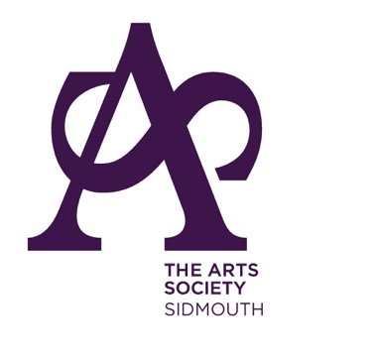
SPECIAL INTEREST MORNING

Thursday 29th May 2025
10am – 1pm at Sidmouth Rugby Football Club

A Study of Sculpture: The Classic to the Modern

A two-lecture special interest morning

By David Worthington

David Worthington graduated from Oxford University in 1984 with a degree in Philosophy and Theology, going on to study fine art in London, Barcelona and New York. Working primarily as a sculptor in stone, he has 25 years professional practice including working as a carver for Anish Kapoor. He works from an old dairy barn studio in Bridport where he combines traditional carving with the latest cutting-edge design and collaborates with architects, engineers, civic bodies and contractors as required. David is a Fellow of The Royal Society of Sculptors and was shortlisted for the Jerwood Sculpture Prize in 2009. He has carried out public commissions in the UK, America and Japan; his work is in the Creative Cities Collection of Beijing and has had solo shows in prestigious galleries throughout the world.

Lecture 1: Rodin is one of the heroic figures of 19th century art history and was internationally celebrated during his lifetime. This lecture surveys his work showing why he is one of the greatest sculptors ever; it looks at his work in relationship to 19th century sculpture as well assessing his continuing influence on the work and practice of sculptors today.

Lecture 2: Brancusi, the son of a peasant from Romania, became an internationally famous artist and is now seen as one of, if not the, most important sculptors of the 20th century. Brancusi is an enigmatic contradiction, and this will be explored in the lecture, along with his relevance to 20th century sculpture.

The cost of the day, including coffee, will be £25 per person.
Payment can be made by BACS (preferred method) to:
The Arts Society Sidmouth; Sort Code: 405240; Acc. No. 00060214
If you do pay by BACS, there is no need to fill out the form below but please call or email me first to ensure the event is not fully booked.
catherinebech10@gmail.com 01395 708693/07717743348

Alternatively, complete the form below and send with your cheque to:
Catherine Bech, 1 Sea View Terrace, Higher Hill View, Sidmouth, EX10 9DQ.
--------------------------------------------------------------------------------------------------------------
Please reserve .……….. places at £25 each for the Special Interest Morning on Thursday 29th May. I enclose my cheque payable to The Arts Society Sidmouth.

Name/s:

Email: Phone no:

