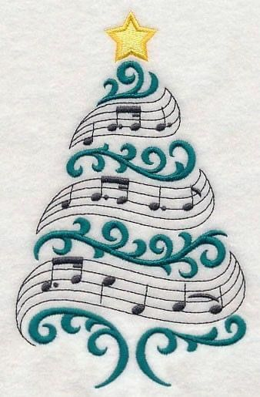
NORTHERN VOICES CHRISTMAS CONCERT
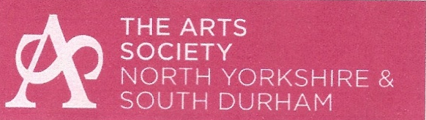
supporting

Festive Carols and Readings Old and New

SATURDAY 29th November 2:00pm
Elm Ridge Methodist Church, Darlington.
Musical Director: Gillian Sild
Accompanist: Stephen Sild
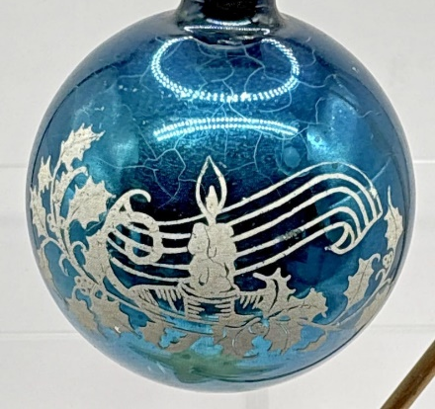
Tickets £8.

