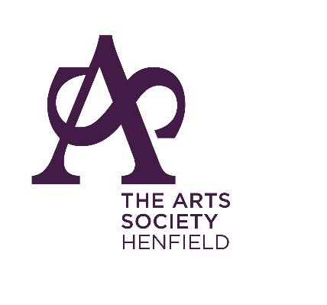
THE ARTS SOCIETY HENFIELD
Do you enjoy hearing about artists, musicians, sculptors, weavers cartographers, illustrators, printers, gold, or silversmiths?
Does their private life fascinate you?
Do you know how or why some became famous whilst others are lost to history?
Then why not join us for a monthly talk in Henfield Hall.
We choose a wide variety of topics and you too can ask for a specific subject to be included.
All that and coffee too with a friendly group of members.
The second Monday afternoon each month at 2.00pm. Come for a taster session (£10 entry) before joining at only £50 per annum.

