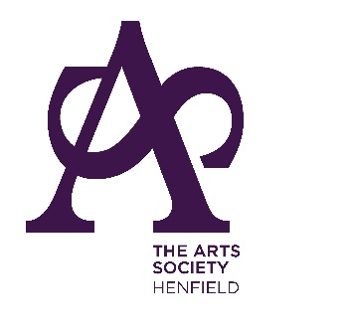

Subscription renewals
The annual subscription for 2024 is £50 per person. Payment should be made no later than 1 December 2023. Programmes for next year will then be distributed.

Those paying by previously set up Standing Order should ensure that the payment has been amended to £50 per person.

Payment may either be
on line, with automatic renewal activated, to
Account No: 10746285
Sort Code: 53-50-39
Reference: Please put your name and membership number (this can be found on the reverse side of your lime green membership card). This is our preferred payment method.
Or
by cheque made payable to “The Arts Society Henfield” and posted to The Membership Secretary

Jenny Ives
Hacketts Cottage,
Church Lane, Henfield,
BN5 9NZ
Thank you in anticipation. Your support is vital to the continued success of our society.

