The Arts Society Welwyn Garden ‘Pop-up’ Trip

Sir John Soane’s Museum, 13 Lincoln’s Inn Fields, London
Friday 24 May 2024

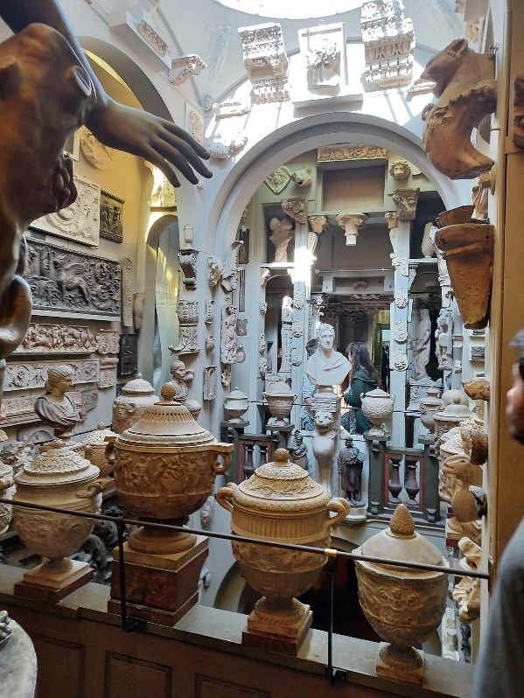

Discover the extraordinary house and museum of architect Sir John Soane and his vast collection of antiquities, furniture, sculptures and paintings.
Our visit will begin with an introductory talk, and includes the Museum’s new exhibition ‘Fanciful Figures’ – an exploration of the small human figures that animate architects’ drawings past and present

Cost: £10.00 per person
Departure: Meet outside the main entrance to the Museum at 1.50pm ready for our group introductory talk at 2.00pm

Location: Sir John Soane’s Museum is at no 13 Lincoln’s Inn Fields, London. Holborn tube station (on the Piccadilly line) is a 5 minute walk away. The visit is scheduled to last 1 hour and 15 minutes. Note: there is no café at the Museum.

To book your place email Helen Smith at welwyngarden@theartssociety.org

Pay by bank transfer: Barclays Bank
Sort code: 20-92-54
Account no: 60945870

OR by cheque payable to The Arts Society Welwyn Garden. Post your cheque to Helen Smith, 7 Hertford Road, Tewin, AL6 0J. If you don’t have an email address, please enclose a SAE for confirmation.

