THE ARTS SOCIETY BRUSSELS
GUIDED VISITS PROGRAMME 2024
REVISED

MARCH 03, 2024 – 14:30
Maison van Eetvelde by Horta –  Avenue Palmerston 4, 1000 Brussels  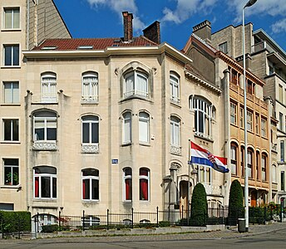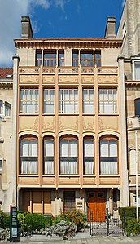 | To round off our discoveries of Victor Horta, come and explore one of his best creations. Built in 1895 for Edmond Van Eetvelde, Secretary General for the Congo, who wanted to show his social success with a house that could accommodate receptions. Distinctive of the Horta style, the house has a superb rotunda glass roof which has been renovated lately and many original elements. It was classified as a UNESCO World Heritage Site in 2000.  Weather permitting, for those who wish, we can take a short walk around the area to see other emblematic Art Nouveau houses.
Price : Guide : 16€ + entrance ticket Members : 10€; Non-members: 15€. No Photos allowed inside.

March 24 2024 – 13:30
Histoire de n,e pas rire, the Surrealism in Belgium’, Bozar, , rue Ravenstein, 1000 Brussels  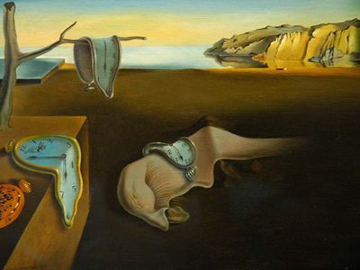 | “Don’t laugh” lets jump forward to Belgium’s renowned Surrealist movement in a comprehensive exhibition, celebrating its 100th anniversary.  Need one say more?
Price: Members 20€ ; Non-members 25€; Museum Pass holders: 12€ for guide€ Limited to 15 people

APRIL 14, 2024 – 15:00
The Fantastic Garden of Tom Frantzen -  Sentiers du Waaienberg, Overijse  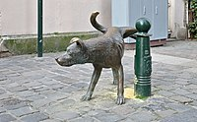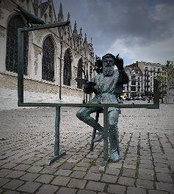  Meandering through town you may have encountered ‘Madame Chapeau’ or ‘Zinnekepis’ (pictured) or Breughel on the Place de la Chapelle. | After all the Art Nouveau, a totally different art form strolling in a garden.  Tom Frantzen, describes his style, characterized by humour and imagination, as Contemporary Flemish Fantastic Art. It is a form of satirical surrealism which is mostly inspired by human behaviour. In all his sculptures he looks for spatial dynamics. He often combines minimalist forms in steel, stone, concrete or wood, with organic forms in bronze.  Among the most important sculptures in his garden there is « The Progression of Human Folly ». It is 14m long and took 8 years of work. It expresses inhumane humanity through the ages. Other fantasist animal sculptures will also amuse you.
Price: Seniors & students; 14€

MAY 26, 2024 – all day
Eperon d'Or, Izegem (near Courtrai)  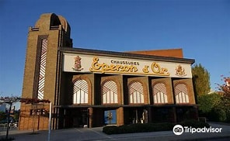  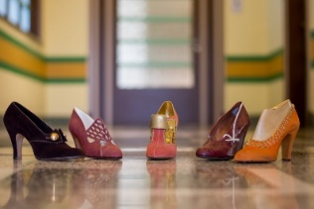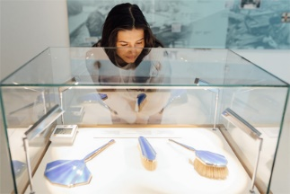 | Did you know that Belgium had its own shoe factory, accredited to the royal courts of both Belgium and Luxembourg?  Or would you rather know more about brushes? A brush is never just a ‘brush’ because there are so many more types of brushes than you can imagine. Rich families used to show off luxurious hat, moustache and piano brushes. Chinese calligraphy art is entirely based on brushes. And what would Harry Potter be without his faithful Nimbus magic broom?  Come for a day’s outing to discover a little visited town, an Art Deco building, a shoe museum and a brush museum.

Train: 1hr39 - Eperon d’Or is within walking distance (100m) of Izegem train station.
Price: 8€ + transport (Seniors 7.80€) + lunch

JUNE 09, 2024 – 15:00
Plantentuin Meise, Nieuwelaan 38, 1860 Meise (outskirts of Brussels, near the Atomium)  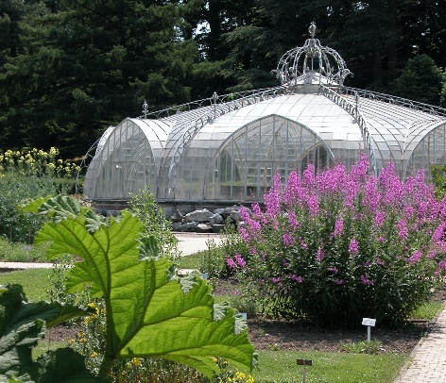 | Come for a walk in scenic botanical gardens. The history of Meise Botanic Garden goes back more than 200 years. It is one of the largest botanical gardens in the world: 92 ha. full of plants. Here, they play the leading role, but don’t forget that played by its castle which witnessed the tragic end of Empress Charlotte of Mexico, only daughter of King Léopold I and his first wife, Louise d’Orléans.
Price: Museum Pass: free; Senior Members: 11€: Non-members: 15

Registration: brussels@theartssociety.org
Payment: The Arts Society Brussels : BE51 3100 5407 5162
(Ref. Guided Visit + date and name of venue
Further information: will be sent before the event or call
Marzia: 0489/64.56.76

