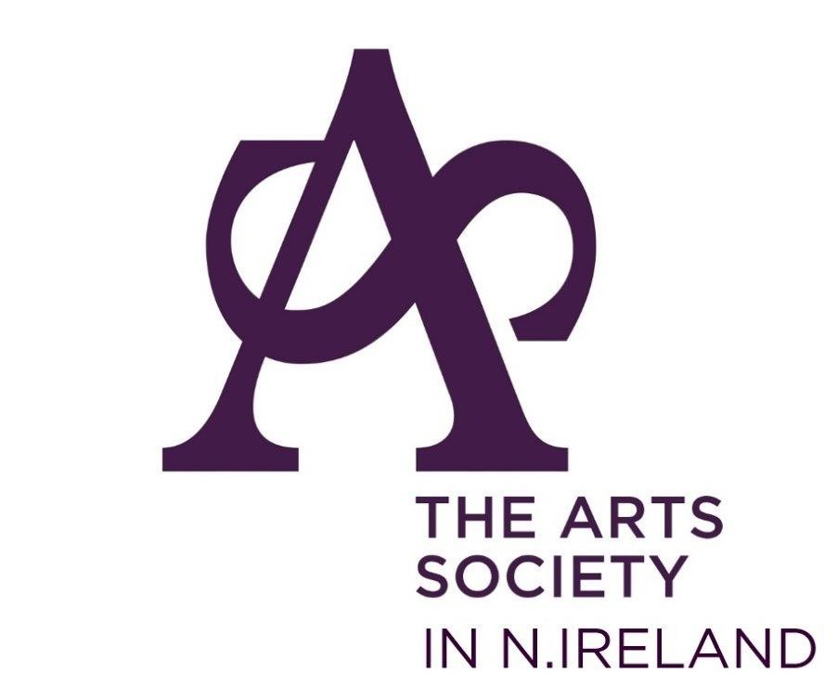
Annual Membership Renewal Form 1st May 2024 – 30th April 2025
Electronically: to Ulster Bank; Account name; Arts Society in N.Ireland;
Sort code: 98-12-90. Account 80526031. Please include your name as the reference.
Then email this completed form to rupert.machenry@ntlworld.com. If you can’t email this form then simply send an email with your details as requested on the form!

OR

Snail Mail: Please complete (block letters), and return this form, with your cheque made out to “ASNI” to our Honorary Treasurer:

Miss Olive Gamble, 8 Islandhill, Drumiller, Dromore, BT25 1HA

I wish to join the Arts Society in N. Ireland as a Single member: £65
We wish to join the Arts Society in N. Ireland as Joint members: £119
[please tick beside the box as appropriate]
Title and First Name …………………………………………………………
Surname/s …................................................................................

Address ………………………………………………………………………….

………………………………………………… Post Code…………………….

Telephone/Mobile number …………………………………………………

E-Mail address …………………………………………………………………

And please tick here to confirm we can contact you via your email.

Members’ addresses and Data Protection Act
- Members’ details will be processed fairly and lawfully and in
accordance with the Society’s legitimate activities.
- Members’ detail will be disclosed to The Arts Society for the purposes of mailing the quarterly Arts Society magazine.
- Members’ details may be disclosed to the Arts Society Area, other
Arts Society Member Societies or organisations affiliated to the Society.

