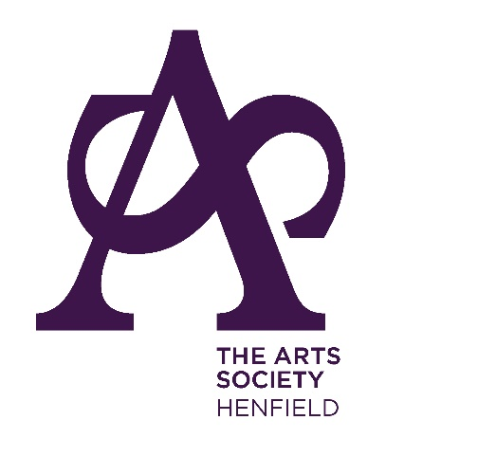
The Arts Society Henfield was founded in 1969 as Adur Valley Fine Arts Society. We are part of the large umbrella organization now known as The Arts Society (T.A.S.), formerly the National Association of Decorative and Fine Arts Societies (N.A.D.F.A.S.), which was founded in 1968. We are the T.A.S. affilliated society serving the communities of Henfield, Cowfold, Partridge Green, Hurstpierpoint, Hassocks, Ditchling, and surrounding localities. Many of our members also join us from as far away as Steyning, Shoreham, Hove, Brighton, and Horsham.
Our Society is now one of the 388 member societies of T.A.S. that have been formed throughout the United Kingdom, in parts of Europe and in Australia and New Zealand.
We meet at the Henfield Hall, Coopers Way, Henfield, West Sussex BN5 9EQ at 2.30 pm on the second Monday of every month except July and August, the season running from January to December.
Entertaining and informative lectures by leading speakers on art, architecture and cultural subjects run for an hour, and are followed by a cup of tea. The meetings are open to members who may bring a guest, at a cost of £8. The annual subscription, for 10 lectures, costs £40 per annum. It is valid from the end of December for one year, but generally we appreciate payment by the end of the preceding November. Those members who have signed up for standing order payments will need to let their respective banks know of any changes. We believe that B.A.C.S. payments by internet banking is the future. Details of our accounts are on the renewal form.
Please see the news item below regarding subscription renewals. In addition to the lecture programme, there are three Days of Special Interest annually. These are devoted to specific subjects and always include lunch. There are three day-trips to interesting cultural venues and one evening lecture, followed by wine and cheese. Occasionally, there are holidays abroad with exceptional guides. The days of special interest, trips, and foreign visits are at extra cost.

