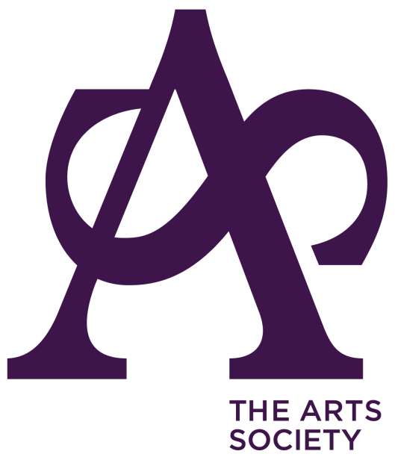
CHARITY GIFT AID DECLARATION
Your donation will help preserve our artistic heritage, support the skills of artists and makers, and improve access to the arts for all. Thank you.
Gift Aid is claimed by The Arts Society from the tax you pay in the current year.
Your address is needed to identify you as a current UK tax payer.

YOUR Details

Title …………………… First name ……………………… Surname ………………………….

Address …..………………………………………………………………………………….………...….
………………………………………………………………………… Postcode ……………………….
Date ……. / ……. / …….

Please tick the box that applies.

I want to Gift Aid

all donations I have made for the 4 years prior to this year, and all donations I make from the date of this declaration until I notify you otherwise.*

all donations I make from the date of this declaration until I notify you otherwise.

I am a UK taxpayer and understand that if I pay less Income Tax and/or Capital Tax than the amount of Gift Aid claimed on all my donations in that tax year it is my responsibility to pay any difference.

*Your claim can be back-dated to cover donations from 1 January 2018. If you wish for your previous donations via the affiliation fee to be included, please select the top option.

GUIDANCE NOTES
The completed Gift Aid declaration should be returned to your local Society for processing.
Please DO NOT send the declaration, related correspondence or payment to The Arts Society.

- Please notify your Society if you:

- Want to cancel this declaration
- Change your name or home address
- No longer pay sufficient tax on your income and/or capital gains

- If you pay Income Tax at the higher or additional rate and want to receive the additional tax relief due to you, you must include all your Gift Aid donations on your Self-Assessment tax return or ask HM Revenue and Customs to adjust your tax code.

- If you are a higher rate taxpayer, you can also claim back the difference between the standard and higher rates of tax in your self-assessment tax return.

- Your Society is a member of The Arts Society (the operating name of the National Association of Decorative and Fine Art Societies), which is a registered charity (Registered charity no. England and Wales 1089743). The Arts Society is able to claim Gift Aid on the affiliation fee (donation) paid by you as part of your total annual subscription, which in 2023 is £15.94

- Previous years’ affiliation fees have been:

  - £13.40 in 2019
  - £13.80 in 2020
  - £12.82 in 2021
  - £14.21 in 2022
  - £15.94 in 2023

- Your subscription, which includes the affiliation fee, will be collected by your Society in the usual way.

