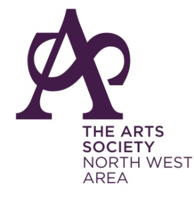
The North West Area Support Team invites you to join our
Tour to the Netherlands, 26th – 31st May 2023
Following the immediate sell-out of our April tour, we have arranged a second tour to take place in May. Again, the main attraction is -
The Vermeer Exhibition at the Rijksmuseum
With loans from all over the world, this promises to be the most important and comprehensive exhibition of Vermeer’s work ever and it is unlikely to be repeated.
Our group will be based in the charming town of Delft, staying at the centrally situated Hampshire Hotel. Our comprehensive tour of the art, architecture and culture of the Netherlands will include:
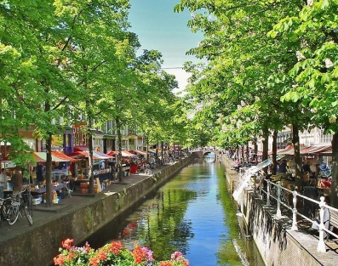
Walking tour of Delft,
Leiden including a canal boat trip and time in the historic Botanic Gardens,
Amsterdam, Rijksmuseum including the Vermeer Exhibition and visit to Amsterdam Palace, Gouda with its Cheese Market and wonderful stained glass in St Janskirk,

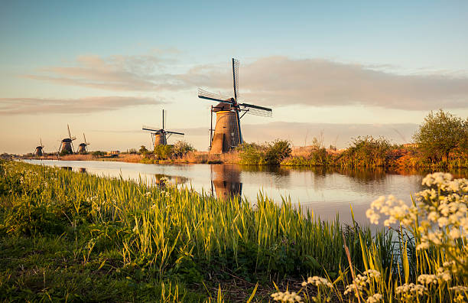
UNESCO World Heritage Site Kinderdijk, with canal boat ride to see the 19 windmills,
The Hague, visiting the Mauritshuis Art Gallery and the Mesdag Panorama,
Haarlem, where we will see the Frans Hals Museum.
The walking content will be gentle and manageable.

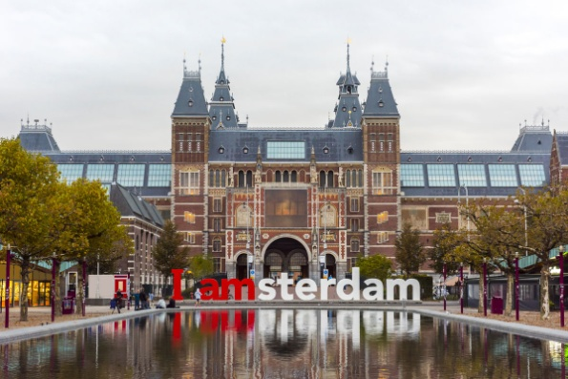
Cost: £1,229.00 per person, single supplement £260.00, to include return flights, five nights’ bed and breakfast, transport by coach to venues, entrance fees, welcome drinks on the first evening, two dinners at the hotel, farewell dinner at a local restaurant focussing on regional specialities, and the services of a tour manager.

For a full brochure please contact Sue O’Brien: suegreenfoot@outlook.com
Or Travel Editions: tours@traveleditions.co.uk

