Directions to the theatre at Barr’s Hill School,
Radford Road, Coventry, CV1 4BU

Barr’s Hill School is on the Radford Road, leading out of Coventry towards Radford. Leave the ring road at Junction 9, head north on the B4098 up the hill for 300 yards. Just after the traffic lights enter the school gates on the left. After parking you will see the theatre as you walk towards the school entrance.

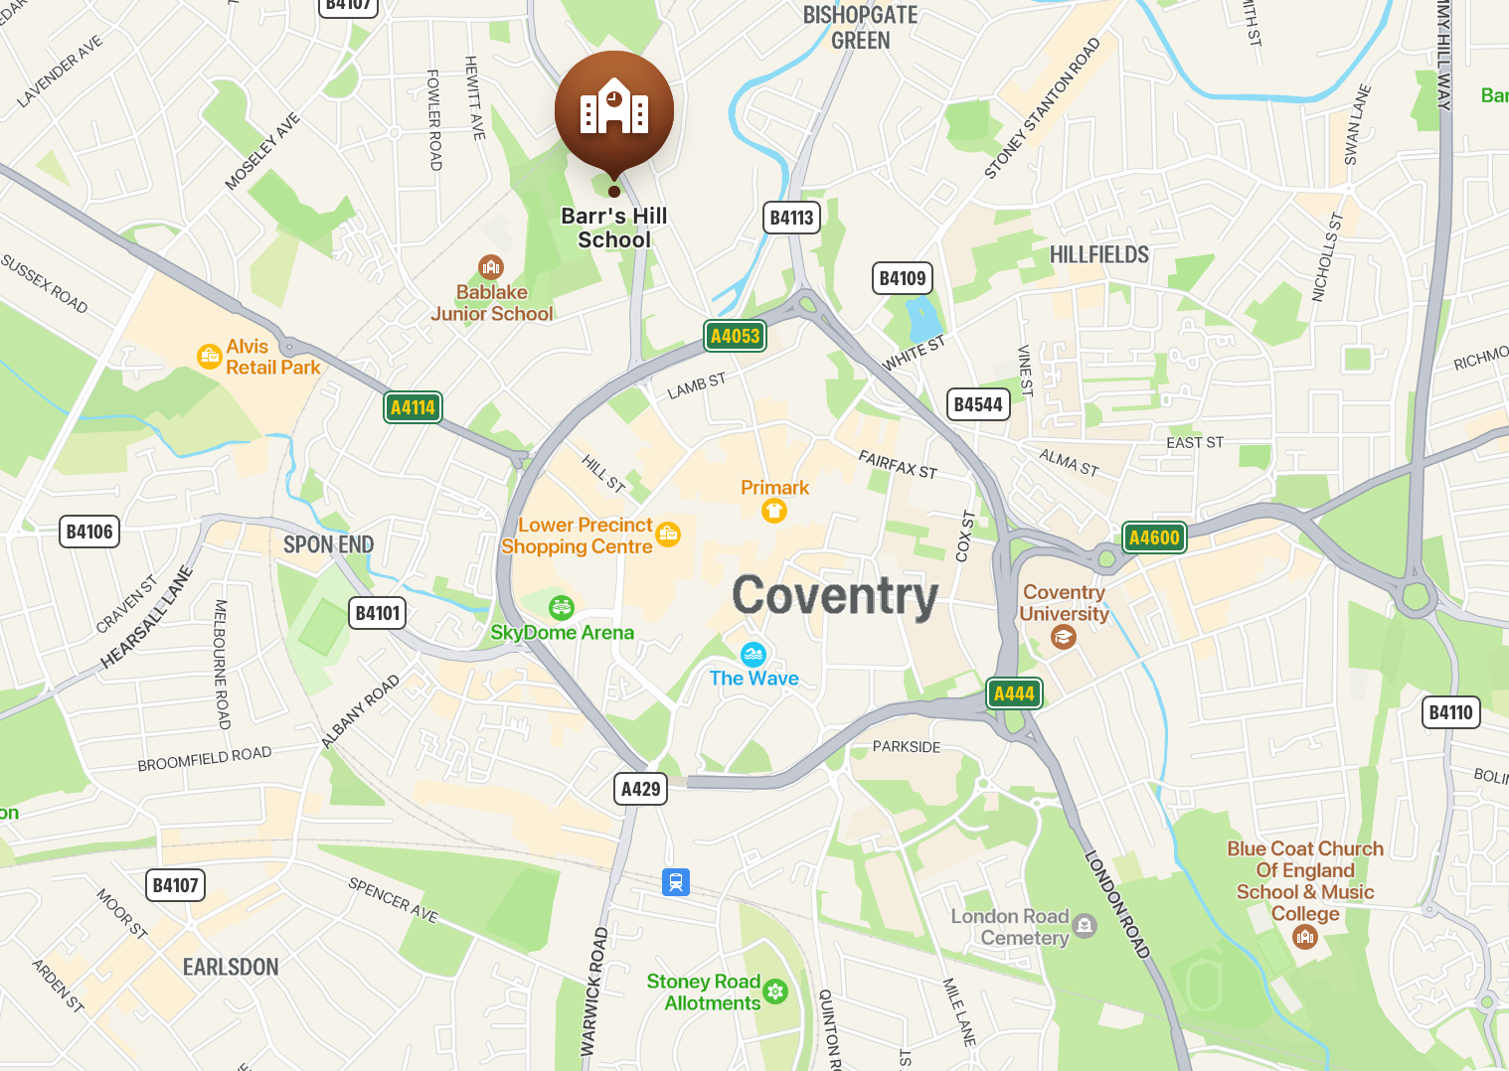

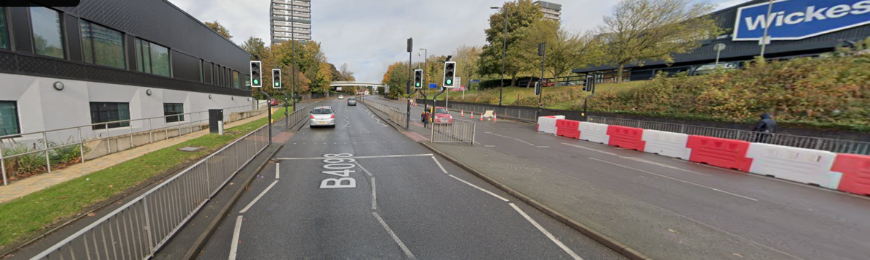
View up the Radford Road after exiting ring road at junction 9.

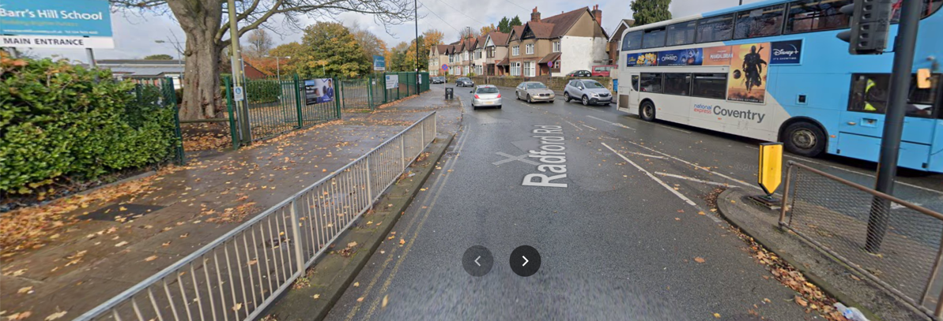
From the ring road, 300 yards at top of the hill, turn left here just past the guard rails.

.

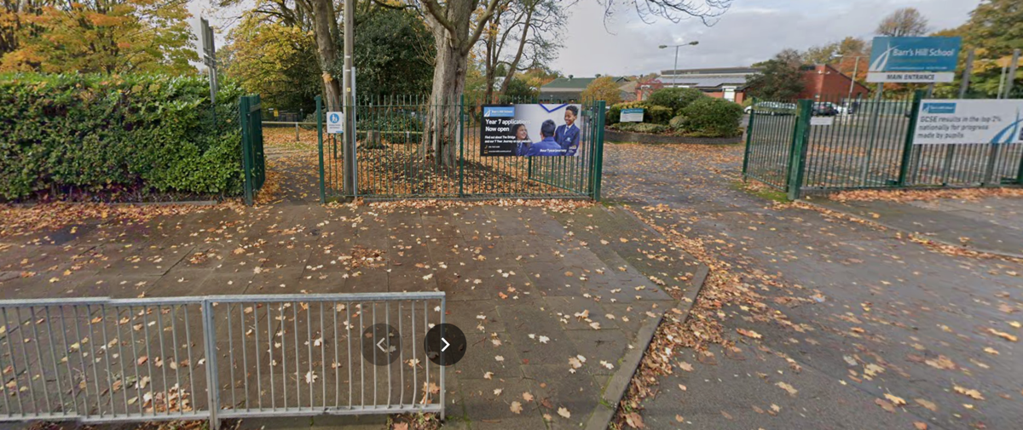
Enter through the gates and park on the right.

Travel by bus
From Coventry City centre, take the no 16 bus from the Transport Museum (stop Hs1, close to entrance to Pool Meadow bus station). Catch the 18.22 and alight four stops later outside Barr’s Hill School.

