RIVER OF LIGHT – THE SEINE – BIRTH OF IMPRESSIONISM
With Carole Petipher

AN ESSEX AREA DAY OF SPECIAL INTEREST MONDAY 24 April 2023

Little Baddow Memorial Hall, Little Baddow, Chelmsford CM3 4TA
Cost £38 per person

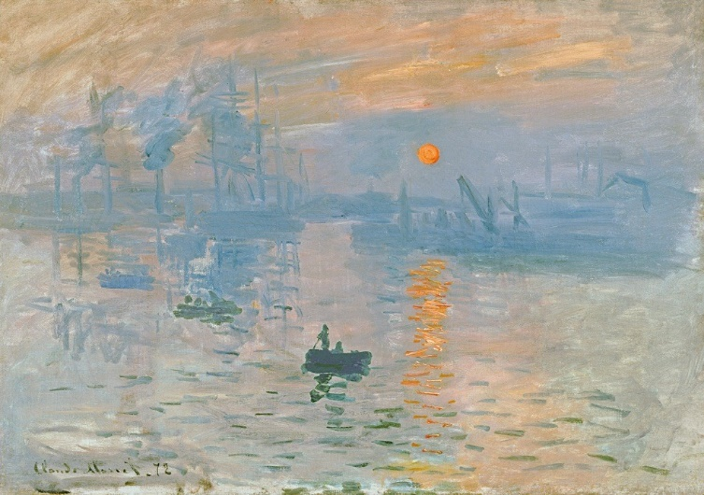

PROGRAMME
10.00 | Registration & Coffee
10.30 | Lecture 1
11.30 | Break
11.45 | Lecture 2
12.45 -13.30 | Lunch
13.30 -14.30 | Lecture 3

This wonderful river in France, often referred to as the River of Light, was a great influence on the 19th Century artists and the development of Impressionism. From the luminescent estuary which first attracted them, to the area west of Paris which became known as the Cradle of Impressionism, they came in their droves to seek inspiration. These three lectures follow the course of the river, a travelogue with the Impressionists at its core, tracking their exploits along it and uncovering new revelations.

Please address enquiries and to book a place to:
Mrs Megan Bashir, Kumra Lodge, Kelvedon Hatch, Brentwood CM15 0JX. TEL: 01277 374314
Email: meganbashir@gmail.com

