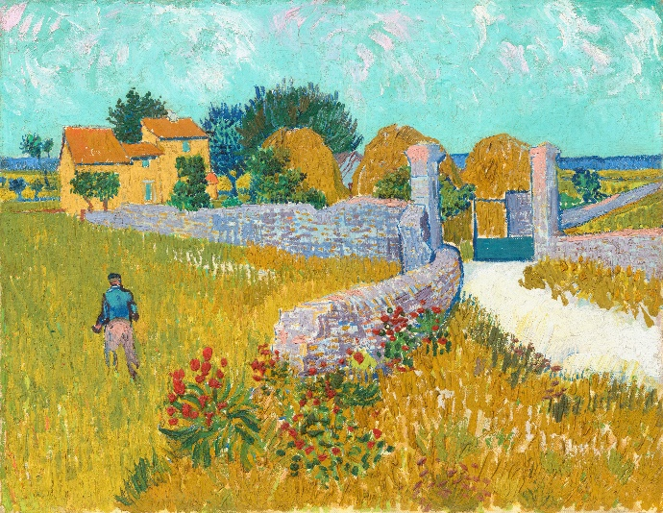

**Van Gogh’s 444 Days**

**in Provence**

**By the Dutch Art Historian**

**Mariska**

**Beekenkamp-Wladimiroff**

**Additional Event – Lecture and Lunch: £26 per person**

**Wednesday October 23rd 2024 10.30am – 2pm**

**Ardingly College Prep School**

This lecture will complement the upcoming exhibition which is part of The National Gallery’s bicentenary celebrations.

**Van Gogh: Poets and Lovers**

**The National Gallery 14.9.2024 – 19.1.2025**

The exhibition will focus on the artist’s period in Provence where he painted some of his most famous, brightest and expressive works.

As well as looking at the works that will feature in the exhibition the lecture will look at his own personal struggles and ambitions, the art that influenced him and the art that he wanted to create.

Despite his time in Provence being quite short and Vincent not finding the support or recognition that he craved, the paintings he created

in the South of France would become some of the most influential, recognisable and loved paintings ever made by an artist.

NB These images give a flavour of what to expect at the exhibition but do not necessarily reflect the works that will be included.

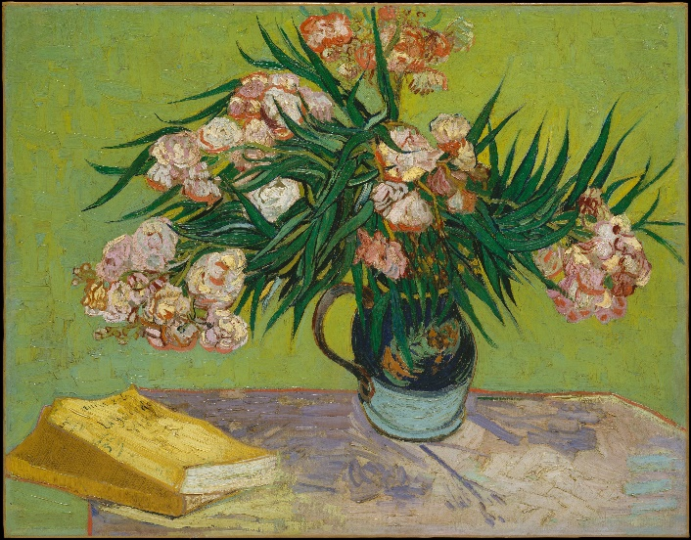

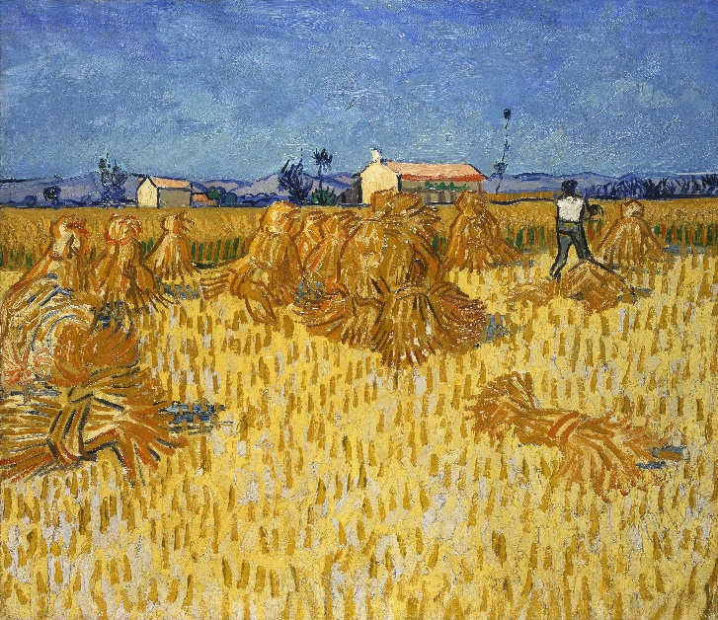

The format will be:

10.30am Coffee/tea

11am Lecture

12pm onwards: Lunch

2 course hot buffet lunch served with wine or a soft drink

We have the prep school drama studio for the lecture. Coffee and lunch will be in the prep dining hall.

As you are aware this is a large campus so we have summarised below some key points re accessibility and the cloakroom facilities.

**Parking**

Disabled spaces are available near the prep school and these are about 100yds flat walk to the studio. These can be allocated so let us know well in advance if this would be helpful. Additional parking is available in the visitors’ area to the front of the campus – this is a short walk to the prep school and it is slightly uphill.

**Dining Hall**

This is split level and there are a couple of steps when taking the shortest route between the studio and the dining hall and we can offer assistance as necessary

**Lunch**

This will be a 2 course hot buffet meal served with wine or a soft drink.

The servery is up a couple of steps, but there is a ramp and we can also offer table service – just let us know.

**WCs**

Gents and ladies are a short flat walk from the studio and additional facilities are up a couple of steps from the dining hall. The disabled WC is further away to the front of the building – please let us know if you wish to use this facility.

**Wheelchair access**

Please let us know if you are using a wheelchair and we can discuss individual requirements.