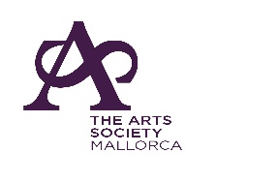 Membership Application Form

The Arts Society Mallorca
(Member Society of The Arts Society)

Please complete (in block letters) and return this form to:

membershipmallorca@theartssociety.org

We will issue a membership card on receipt of the appropriate payment, see below.

I wish to join The Arts Society Mallorca as a single member €70
We wish to join The Arts Society Mallorca as joint members €120
(delete as appropriate)
Payment should be made by bank transfer to:

LA SOCIETE DE LOS ARTES
C Coma 19, 07183 Costa de la Calma

IBAN: ES88 0081 0538 1500 0131 2237
BIC: BSABESBB

Name(s)______________________________________________________

Address:______________________________________________________

___________________________________ Postcode:__________________

Tel:____________________________ E-mail:________________________

The Arts Society Mallorca is always looking for volunteers to help with the running of the Society. Please tick here if you would be willing to help.

Preferred method of communication
So that we can let you know about Society news and events, please tick the relevant box to indicate how you would prefer to be contacted by us in future.
Email (preferred) Telephone

GDPR Compliance:
- Members’ details will be processed fairly and lawfully in order to satisfy the agreement entered with you on your admittance to membership. This will ensure that you receive the latest news and information about all upcoming events.
- Members’ details will be passed to “The Arts Society” to enable inclusion on the mailing of the quarterly magazine and other communications including information about any upcoming national events or items of legitimate interest
- Members’ details may be passed to “The Arts Society Area”, or other affiliated societies for the purposes of disseminating relevant information of legitimate interest
- Your details will be kept safely and securely and you have the ability to opt out of our communications at any time
Please tick here if you have accessibility issues.

