OBJECTS MADE BY FAITH-CRAFT WORKS

Faith Craft (variously known as Faithcraft or Faith-Craft Works or Faith Craft Studio) was a business arm of the Society of the Faith producing a wide range of products for churches from c1916 until its closure in 1973. Their records were destroyed by the Society at the time of closure so there are no records of work done or artists/craftsmen employed.

The Society is compiling a list of works on their website www.societyofthefaith.org.uk
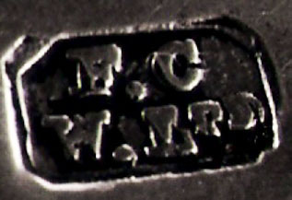
Please give information about any objects in a church which have been produced by Faith Craft, particularly items of precious metal for which the maker's hallmark is shown on the right.

Church
Record Date |  | Town/Village
Parish |  |  | County

Object title
eg chalice
Material
Designer |  | Date
Donor
Commemorated

Details (as in Record)

Photograph(s) attached: (please select) Yes □ No □

Name of Church  Recorders Group |  | Date
Recorder's  name | Recorder's  email
Recorder's
Address

When completed email this form with jpeg image/s to robertssopwellnunnery@btinternet.com

Or post to Mrs Margery Roberts, The Society of the Faith
Faith House
7 Tufton Street
Westminster
London SW1P 3QB

