in the Diocese of [insert Diocese]
[Post Code]
Church of England number [insert no.] National Grid reference [insert]

The Arts Society Record of Church furnishings by the [name of the sponsoring The Arts Society] Group of Church Recorders, started in [year] and completed in [year], during the incumbency of [name of incumbent].

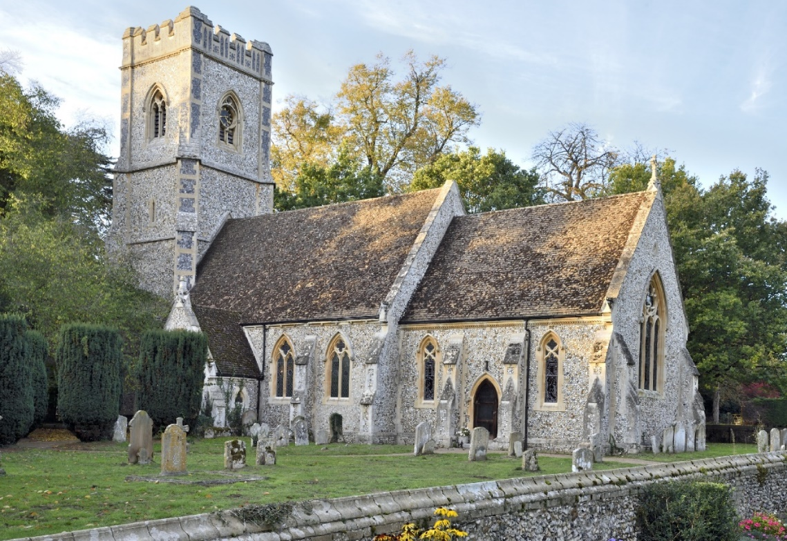
[insert external photograph – as the example]

[brief history of the church including a list of its most significant items and their Section numbers]

[insert west – east photograph]

West - East

[insert east – west photograph]

East – West
[possibly add photographs of side aisles and Chancel of a large church]

[insert whole page church plan]

[Acknowledgements of and dedications of significant financial or other support ]
This Record was supported by The Arts Society [insert name of Society].
We are grateful for the help and interest of the Churchwardens and parishioners.

SECTION NUMBERING | CHURCH RECORDERS
001 -– 099 Memorials | [list their names here]
100 - 199 Metalwork | [list their names here]
200 - 299 Stonework | [list their names here]
300 - 399 Woodwork | [list their names here]
400 - 499 Textiles | [list their names here]
500 - 599 Paintings etc. | [list their names here]
600 - 699 Library | [list their names here]
700 - 799 Windows | [list their names here]
800 - 899 Miscellaneous | [list their names here]
Group Leader: [name]  Photographer: [name] | [list their names here]

Where possible, the numbering of each Section starts at the East end of the Church and continues clockwise around the Church.
The numbers 1 – 10 in the left-hand margin under the item number refer to:
1 Description.
2 Material.
3 Date.
4 Measurements.
5 Artist, Architect, Designer, Sculptor, Woodworker, etc.
6 Manufacturer.
7 History of item or family.
8 Donor and date of presentation to Church.
9 Inscription.
10 References.

Terminology is mostly as used in Inside Churches, A Guide to Church Furnishings, NADFAS 1993 ISBN 0954019105

For enquiries about use of this Record or the TIFF digital photographs of this Record contact:
enquiries@churchrecordingsociety.org.uk
Volunteering@thearstsociety.org
Text and Photographic copyright is vested in The Arts Society (see copyright page)

ABBREVIATIONS
[add or delete as appropriate]
A.M. | Master of Arts |  | LL. D. | Doctor of Laws
c | About or circa |  | lt. | litre
C | Century (14C) |  | M.A. | Master of Art
caps & l/c | capitals and lowercase lettering |  | n/a | Not available
circum | circumference |  | n.d. | No date
cm | centimetres |  | OUP | Oxford University Press
CUP | Cambridge University Press |  | Ph(s) | Photograph(s)
d | died/ depth |  | Pub. | Published
DAC | Diocesan Advisory Committee |  | QQ | Quinquennial inspection
dau | daughter |  | qr | quarter
diam | diameter |  | Rom. caps. | Roman capitals (lettering)
Dr | drawing |  | SPCK | Society for the Promotion of Christian Knowledge
est. | estimate |  | T&I | Terrier and Inventory
g. | weight in grams |  | vol. | volume
h. | height |  | w. | width
inc. | including |  | wt. | weight
l. | length |  | [and any others used]

BIBLIOGRAPHY & SOURCES

[list books, papers and other media]

Other Sources
[list expert and other sources]

SUMMARY OF NAMES in this Record [list the exclusions, which are long lists and References. For example: “excluding the War Memorial (005), Roll of Honour (010), Kneelers (412), Benefaction Board (504), Peal Board (507), List of Incumbents (509), Registers and Records (600).”]

[surname]  [surname]  [etc.] | [first names]  [first names] | [object number/s in Record]  [object number/s in Record]

SUMMARY OF ARTISTS, SCULPTORS, MANUFACTURERS etc (excluding general printers and publishers)

Name | Trade or profession | object number

