
THE ARTS SOCIETY CHURCH RECORDING RRRRRRRRRRRRRRECORDING RECORECORDING

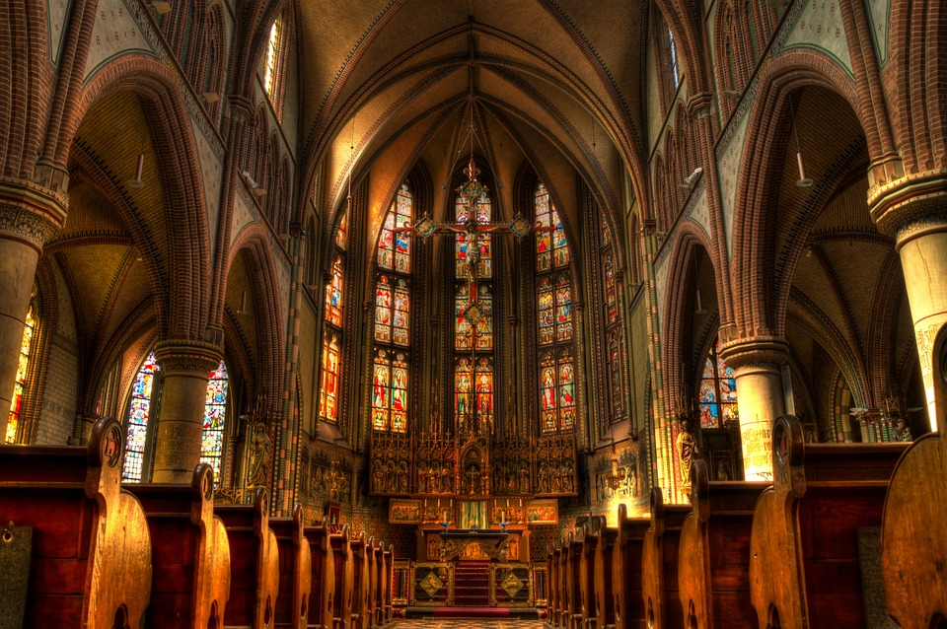
RECORD OF CHURCH FURNISHINGS OF [CHURCH, LOCATION COUNTY]

MADE BY THE CHURCH RECORDING GROUP OF THE ARTS SOCIETY [LOCATION]

